CodeCrest – Competitive Programming & Leaderboard Platform

Table of Contents
- Problem Statement
- Technology Stack
- Project Structure
- Dependencies and Configuration
- Database Configuration
- Entity Models
- Repositories
- Service Layer
- Controller Layer
- Security Implementation
- Exception Handling
- Data Transfer Objects (DTOs)
- Utility Classes
- API Endpoints
- Frontend Component Specifications
- Frontend Service Configurations
- Frontend Store Configurations
- End of Documentation

Problem Statement:
The CodeCrest Competitive Programming Platform is a robust, full-stack curriculum orchestration and contest tracking platform built using React (frontend) and Spring Boot (backend). It enables students, problem setters, and platform admins to manage educational coding challenges, milestone achievements, and contestant enrollment workflows through an intelligent skill-building architecture. The platform prioritizes high-fidelity response handling and granular role-based access control to maintain a professional, competitive environment.

Technology Stack
1. Backend:
- Framework: Spring Boot 3.1.5
- Language: Java 17
- Security: Spring Security with JWT (HS256)
- Persistence: Spring Data JPA
- Database: MySQL
2. Frontend:
- Library: React.js
- State Management: Redux Toolkit
- Styling: Vanilla CSS (App.css)
- Testing: Jest / React Testing Library
3. Build & Tools:
- Maven
- Axios

Project Structure
Backend
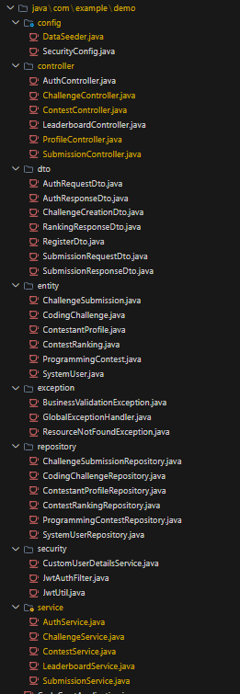

Frontend
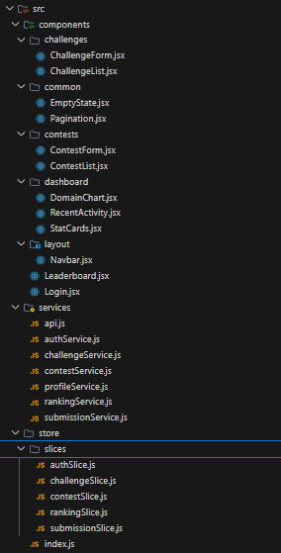

Dependencies and Configuration
1. Backend (pom.xml):
- spring-boot-starter-web
- spring-boot-starter-data-jpa
- spring-boot-starter-security
- spring-boot-starter-validation
- jjwt-api / jjwt-impl / jjwt-jackson (0.11.5)
- mysql-connector-j
-Swagger ui
2. Frontend (package.json):
- @reduxjs/toolkit
- react-redux
- axios
- react-router-dom

Database Configuration
- Database Name: codecrest
- Connection URL: jdbc:mysql://localhost:3306/codecrest
- Credentials: root / root
- Initialization: spring.jpa.hibernate.ddl-auto=update

Entity Models

1. SystemUser Entity (Table: system_users)
- Fields: id (Long), username (String), password (String), role (UserRole Enum).
- Purpose: Represents the core identity for all platform actors (Admins, Setters, Contestants).
- Implementation Requirements: Username must be unique; passwords must be stored as BCrypt hashes.

2. CodingChallenge Entity (Table: coding_challenges)
- Fields: id (Long), title (String), description (String/Text), difficulty (Difficulty Enum), basePoints (Integer), timeLimitMs (Integer), setter (SystemUser).
- Purpose: Stores the problem statements and evaluation metadata for algorithmic challenges.
- Implementation Requirements: Uses `@ManyToOne` for the author relationship and `TEXT` type for long descriptions.

3. ContestantProfile Entity (Table: contestant_profiles)
- Fields: id (Long), username (String), bio (String), totalPoints (Integer), globalRank (Integer), accountStatus (AccountStatus Enum), user (SystemUser).
- Purpose: Maintains the competitive standing and personalized data for each contestant.
- Implementation Requirements: Linked via `@OneToOne` to `SystemUser` with `CascadeType.ALL` to synchronize account lifecycles.

4. ProgrammingContest Entity (Table: programming_contests)
- Fields: id (Long), title (String), startTime (LocalDateTime), endTime (LocalDateTime), capacity (Integer), status (ContestStatus Enum).
- Purpose: Orchestrates competitive programming events and their respective windows of participation.
- Implementation Requirements: Status defaults to `UPCOMING`; timing fields must be validated to ensure start precedes end.

5. ContestRanking Entity (Table: contest_rankings)
- Fields: id (Long), contest (ProgrammingContest), contestant (ContestantProfile), currentScore (Integer), penaltyTime (Integer), localRank (Integer).
- Purpose: Tracks the real-time performance and standing of a contestant within a specific contest.
- Implementation Requirements: Binds `contest_id` and `contestant_id` explicitly to avoid duplicate enrollment logic.

6. ChallengeSubmission Entity (Table: challenge_submissions)
- Fields: id (Long), sourceCode (String/Text), verdict (Verdict Enum), executionTimeMs (Integer), pointsEarned (Integer), contestant (ContestantProfile), challenge (CodingChallenge), contest (ProgrammingContest), submittedAt (LocalDateTime).
- Purpose: Records every code evaluation attempt and its resulting metrics.
- Implementation Requirements: Captures the state of the contest at submission time; uses `@ManyToOne` relationships to all relevant actors and entities.

Repositories

1. SystemUserRepository: Standard CRUD with `findByUsername`.
2. CodingChallengeRepository: Manages algorithmic problem persistence.
3. ContestantProfileRepository: Manages contestant metadata and rankings.
4. ProgrammingContestRepository: Handles competitive event scheduling.
5. ContestRankingRepository: Stores performance records for specific contests.
6. ChallengeSubmissionRepository: Persists all code evaluation results.

Security Implementation

1. security/JwtUtil.java
- Fields: secretKey (String) — injected via @Value from application.properties, used as the signing key for HS256 token generation and validation.
- Implementation: Provides utility methods for token generation, claims extraction (username, role), and validation against UserDetails. Key methods: generateToken(UserDetails), isTokenValid(String, UserDetails).

2. security/JwtAuthFilter.java (JwtRequestFilter)
- Implementation: Extends `OncePerRequestFilter`. Intercepts every HTTP request to extract the "Bearer" token, validate it via `JwtUtil`, and set the `Authentication` object in the `SecurityContextHolder`.

3. security/CustomUserDetailsService.java
- Implementation: Implements `UserDetailsService`. Bridges the security layer with the database by loading a `SystemUser` from the repository and converting it into a Spring Security `UserDetails` object.

4. config/SecurityConfig.java
- Implementation: Configures the `SecurityFilterChain`. Disables CSRF, sets session management to `STATELESS`, and defines public vs. restricted endpoint access rules.

Exception Handling

1. exception/ResourceNotFoundException.java: Thrown when an entity (Challenge, User, Contest) is missing. Returns 404.
2. exception/BusinessValidationException.java: Thrown for invalid logic attempts (e.g., enrolling in a closed contest). Returns 400.
3. exception/GlobalExceptionHandler.java: Centralized `@ControllerAdvice` that catches all exceptions and returns a standardized JSON response: `{"timestamp": "...", "message": "..."}`.

Service Layer

1. AuthService
- `void register(RegisterDto dto)`: Validates username uniqueness; hashes password and initializes a default `ContestantProfile` in `ACTIVE` status. Throws `RuntimeException` if username exists.
- `AuthResponseDto login(AuthRequestDto dto)`: Authenticates credentials via `AuthenticationManager`. Generates a JWT token for the session and returns user metadata.

2. ChallengeService
- `List<CodingChallenge> getAllChallenges()`: Retrieves all authored coding challenges from the repository.
- `CodingChallenge getChallengeById(Long id)`: Fetches a specific challenge by ID; throws `ResourceNotFoundException` if not found.
- `void createChallenge(ChallengeCreationDto dto, String username)`: Maps DTO to entity, associates the author (setter), and persists the new challenge.
- `void updateChallenge(Long id, ChallengeCreationDto dto)`: Synchronizes existing challenge metadata with the provided DTO.
- `void deleteChallenge(Long id)`: Validates existence and removes the challenge record.

3. ContestService
- `List<ProgrammingContest> getAllContests()`: Fetches a comprehensive list of all scheduled and historical contests.
- `ProgrammingContest getContestById(Long id)`: Retrieves contest details; throws `ResourceNotFoundException` if missing.
- `void createContest(ProgrammingContest contest)`: Persists a new competitive event.
- `void updateContest(Long id, ProgrammingContest details)`: Updates timing, capacity, and status for an existing contest.
- `void deleteContest(Long id)`: Removes a contest; throws 404 if not found.
- `void enrollParticipant(Long contestId, String username)`: Validates `UPCOMING` status and existing enrollment before creating a `ContestRanking` record for the contestant.

4. LeaderboardService
- `Page<RankingResponseDto> getGlobalLeaderboard(Pageable pageable)`: Fetches paged contestant profiles sorted by `totalPoints` descending and calculates global ranks.
- `Page<RankingResponseDto> getContestLeaderboard(Long contestId, Pageable pageable)`: Retrieves paged rankings for a specific contest sorted by `currentScore` and `penaltyTime`.

5. SubmissionService
- `SubmissionResponseDto processSubmission(SubmissionRequestDto dto, String username)`: Evaluates code submissions, simulates verdicts (ACCEPTED, etc.), calculates dynamic points based on difficulty/time efficiency, and updates both global and contest-specific scores.
- `void deleteSubmission(Long id)`: Removes a specific submission record; throws `ResourceNotFoundException` if missing.

Controller Layer

1. AuthController (/api/auth)
- POST /register: (Public) 200 OK, returns `ResponseEntity<String>` ("Registration successful").
- POST /login: (Public) 200 OK, returns `ResponseEntity<AuthResponseDto>`.

2. ChallengeController (/api/challenges)
- GET /: (Authenticated) 200 OK, returns `ResponseEntity<Page<CodingChallenge>>`.
- GET /{id}: (Authenticated) 200 OK, returns `ResponseEntity<CodingChallenge>`.
- POST /: (Requires ROLE_PROBLEM_SETTER or ROLE_PLATFORM_ADMIN) 200 OK, accepts ChallengeCreationDto and java.security.Principal. Returns ResponseEntity<String> ("Challenge created")
- PUT /{id}: (Requires ROLE_PROBLEM_SETTER or ROLE_PLATFORM_ADMIN) 200 OK, returns `ResponseEntity<String>` ("Challenge updated").
- DELETE /{id}: (Requires ROLE_PLATFORM_ADMIN) 200 OK, returns `ResponseEntity<String>` ("Challenge deleted").
- POST /{id}/submit: (Requires ROLE_CONTESTANT) 200 OK, accepts Long id, SubmissionRequestDto, and java.security.Principal. Returns ResponseEntity<SubmissionResponseDto>.

3. ContestController (/api/contests)
- GET /: (Authenticated) 200 OK, returns `ResponseEntity<Page<ProgrammingContest>>`.
- GET /{id}: (Authenticated) 200 OK, returns `ResponseEntity<ProgrammingContest>`.
- POST /: (Requires ROLE_PLATFORM_ADMIN) 200 OK, returns `ResponseEntity<String>` ("Contest created").
- PUT /{id}: (Requires ROLE_PLATFORM_ADMIN) 200 OK, returns `ResponseEntity<String>` ("Contest updated").
- DELETE /{id}: (Requires ROLE_PLATFORM_ADMIN) 200 OK, returns `ResponseEntity<String>` ("Contest deleted").
- POST /{id}/enroll: (Requires ROLE_CONTESTANT) 200 OK, returns `ResponseEntity<String>` ("Enrolled successfully").

4. LeaderboardController (/api/leaderboard)
- GET /global: (Authenticated) 200 OK, returns `ResponseEntity<Page<RankingResponseDto>>`.
- GET /contest/{contestId}: (Authenticated) 200 OK, returns `ResponseEntity<Page<RankingResponseDto>>`.

5. ProfileController (/api/profiles)
- GET /: (Requires ROLE_PLATFORM_ADMIN) 200 OK, returns `ResponseEntity<List<ContestantProfile>>`.
- GET /me: (Authenticated) 200 OK, returns `ResponseEntity<ContestantProfile>`. Failure -> 404 Not Found if profile missing.
- PUT /{id}: (Authenticated) 200 OK, returns `ResponseEntity<String>` ("Profile updated").
- DELETE /{id}: (Requires ROLE_PLATFORM_ADMIN) 200 OK, returns `ResponseEntity<String>` ("Profile deleted").

6. SubmissionController (/api/submissions)
- GET /: (Authenticated) 200 OK, returns `ResponseEntity<Page<ChallengeSubmission>>`.
- GET /my: (Requires ROLE_CONTESTANT) 200 OK, returns `ResponseEntity<List<ChallengeSubmission>>`.
- DELETE /{id}: (Requires ROLE_PLATFORM_ADMIN) 200 OK, returns `ResponseEntity<String>` ("Submission deleted").

Security Implementation
- Configuration (SecurityConfig.java): Implements a stateless security filter chain. Disables CSRF, enables CORS, and permits public access to `/api/auth/**`. All other endpoints require JWT authentication.
- Seeding (DataSeeder.java): Automatically initializes the system on startup. Checks if `challengeRepository.count() < 15` and generates algorithmic challenges for pagination testing. Ensures `admin` and `setter` users exist.
- Algorithm: HS256 (HMAC with SHA-256).
- Token Validation: JwtRequestFilter extracts "Authorization: Bearer <token>" and populates SecurityContextHolder.

Exception Handling
- GlobalExceptionHandler.java: Returns ResponseEntity<Object> containing a Map with "timestamp" and "message".
- Successive Handling: Must intercept ResourceNotFoundException and return 404 NOT FOUND with specific error detail.

Data Transfer Objects (DTOs)

1. dto/AuthRequestDto
- Fields: username (String), password (String).
- Purpose: Input payload for user authentication (login) requests.

2. dto/AuthResponseDto
- Fields: token (String), user (Nested UserDto).
- Purpose: Output payload containing the session token and user metadata upon successful authentication.

3. dto/ChallengeCreationDto
- Fields: title (String), description (String), difficulty (Difficulty Enum), basePoints (Integer), timeLimitMs (Integer).
- Purpose: Input payload for authoring or updating algorithmic coding challenges.

4. dto/RankingResponseDto
- Fields: rank (Integer), username (String), score (Integer).
- Purpose: Output payload representing a single contestant's rank and performance metrics on the leaderboard.

5. dto/RegisterDto
- Fields: username (String), password (String), bio (String).
- Purpose: Input payload for new contestant account registration.

6. dto/SubmissionRequestDto
- Fields: challengeId (Long), contestId (Long), sourceCode (String).
- Purpose: Input payload for submitting a solution to a coding challenge.

7. dto/SubmissionResponseDto
- Fields: submissionId (Long), verdict (String), pointsEarned (Integer), executionTimeMs (Integer), message (String).
- Purpose: Output payload returning the evaluation results and feedback for a code submission.

Utility Classes
- JwtUtil.java: Provides generateToken(UserDetails) and isTokenValid(String, UserDetails).

API Endpoints
- Base URL: http://localhost:8080/api
- Auth: /api/auth/login, /api/auth/register
- Challenges: GET /api/challenges, POST /api/challenges, DELETE /api/challenges/{id}
- Contests: GET /api/contests, POST /api/contests, POST /api/contests/{id}/enroll

Frontend Component Specifications

1. components/Login.jsx
- Requirements: Implements a managed form with `username` and `password` state. Integrates with `authSlice` via `useDispatch`.
- Implementation: Displays "username" and "password" inputs with `placeholder="Enter username"` and `placeholder="Enter password"`. Submit button triggers `loginUser` thunk and shows "Logging in..." during `pending` state. Redirects to `/dashboard` upon success.

2. components/common/Pagination.jsx
- Requirements: Stateless component receiving `currentPage`, `totalPages`, and `onPageChange` as props.
- Implementation: Compact UI with `<` (Previous) and `>` (Next) icon buttons. Page indicator displayed as "Page X of Y" in a square bordered box. Right-aligned using Flexbox within `.pagination-container`.

3. components/common/EmptyState.jsx
- Requirements: Reusable fallback UI for empty data arrays.
- Implementation: Renders a centralized container with a 📂 icon (font-size: 48px) and a customizable `message` prop (default: "No data found"). Uses subtle gray text colors.

4. components/challenges/ChallengeList.jsx
- Requirements: Primary interface for viewing algorithmic problems. Connects to `challengeSlice`.
- Implementation: Renders a "Coding Challenges" header. Displays a paged data table with columns: Title, Difficulty (color-coded), and Base Points. Role-restricted "Add Challenge" button visible only to ADMIN/SETTER.

5. components/challenges/ChallengeForm.jsx
- Requirements: Multi-purpose form for CREATE/EDIT operations.
- Implementation: Captures `title`, `description` (textarea), `difficulty` (dropdown), and `basePoints`. Enforces HTML5 `required` attributes. Dispatches `createChallenge` thunk and handles modal closure or navigation on success.

6. components/contests/ContestList.jsx
- Requirements: Displays all scheduled programming contests.
- Implementation: List view with status indicators: `UPCOMING` (Blue), `ACTIVE` (Green), `COMPLETED` (Gray). "Enroll" button is disabled if the user is already enrolled or if the contest is `COMPLETED`.

7. components/contests/ContestForm.jsx
- Requirements: Admin-exclusive form for scheduling events.
- Implementation: Includes datetime-local inputs for `startTime` and `endTime`. Validates that `startTime` is in the future and precedes `endTime`. Captures `capacity` as a positive integer.

8. components/dashboard/StatCards.jsx
- Requirements: High-level metric overview for the contestant.
- Implementation: Grid layout of bordered cards. Maps specific icons to metrics: 🏆 for "Global Rank", ⭐ for "Total Points", and ✅ for "Challenges Solved".

9. components/dashboard/DomainChart.jsx
- Requirements: Visual breakdown of performance by category.
- Implementation: Uses CSS-based bar heights to represent solved counts across domains (e.g., Arrays, Math, DP). Bars are color-coded based on the domain's average difficulty.

10. components/dashboard/RecentActivity.jsx
- Requirements: List of the latest 5 solution attempts.
- Implementation: Fetches data from `submissionSlice`. Displays `Challenge Title`, `Verdict` (color-coded: ACCEPTED = Green, WRONG = Red), and a formatted timestamp.

11. components/layout/Navbar.jsx
- Requirements: Persistent top navigation with role-aware links.
- Implementation: Displays "CodeCrest" branding. Links to "Challenges", "Contests", and "Leaderboard". Right-side shows "Welcome, {username}" and a "Logout" button that clears Redux state and `localStorage`.

12. components/Leaderboard.jsx
- Requirements: Global ranking table.
- Implementation: Fetches paged data from `rankingSlice`. Columns: Rank, Username, and Total Score. Highlights the current user's row with a subtle background color.

Frontend Service Configurations

1. services/api.js
- Implementation: Configures a global Axios instance with `baseURL: http://localhost:8080/api`. Implements a `request interceptor` to automatically attach the JWT token from `localStorage` to the `Authorization` header for all outgoing requests.

2. services/authService.js
- Implementation: Provides `login(credentials)` and `register(userData)` methods. Handles the low-level `POST` requests to `/auth/login` and `/auth/register`.

3. services/challengeService.js
- Implementation: Provides `getAll(page, size)`, `getById(id)`, `create(data)`, and `delete(id)` methods. Facilitates challenge lifecycle management.

4. services/contestService.js
- Implementation: Provides `getAll(page, size)`, `getById(id)`, `create(data)`, and `enroll(id)` methods. Manages contest-specific API interactions.

5. services/profileService.js
- Implementation: Provides `getProfile(username)` and `updateProfile(data)` methods. Interacts with `/api/profiles` endpoints.

6. services/rankingService.js
- Implementation: Provides `getGlobalRankings(page, size)` method. Fetches leaderboard data from `/api/leaderboard/global`.

7. services/submissionService.js
- Implementation: Provides `submit(data)` and `getSubmissions(contestantId)` methods. Handles code evaluation requests to `/api/challenges/{id}/submit`.

Frontend Store Configurations

1. store/index.js
- Implementation: Central Redux store configuration using `configureStore`. Combines all slices (auth, challenges, contests, rankings, submissions) into a single root reducer.

2. store/slices/authSlice.js
- Implementation: Manages authentication state (`user`, `token`, `isAuthenticated`). Handles `login` and `logout` actions. Synchronizes state with `localStorage`.

3. store/slices/challengeSlice.js
- Implementation: Manages challenge data, pagination state (`totalPages`, `currentPage`), and loading/error states. Reducer filters out the deleted challenge upon `deleteChallenge.fulfilled`.

4. store/slices/contestSlice.js
- Implementation: Manages contest lists and enrollment status. Handles `fetchContests` and `enrollParticipant` async thunks.

5. store/slices/rankingSlice.js
- Implementation: Manages leaderboard data and global ranking statistics.

6. store/slices/submissionSlice.js
- Implementation: Manages submission history, verdicts, and real-time processing states for code submissions.

Demo UI

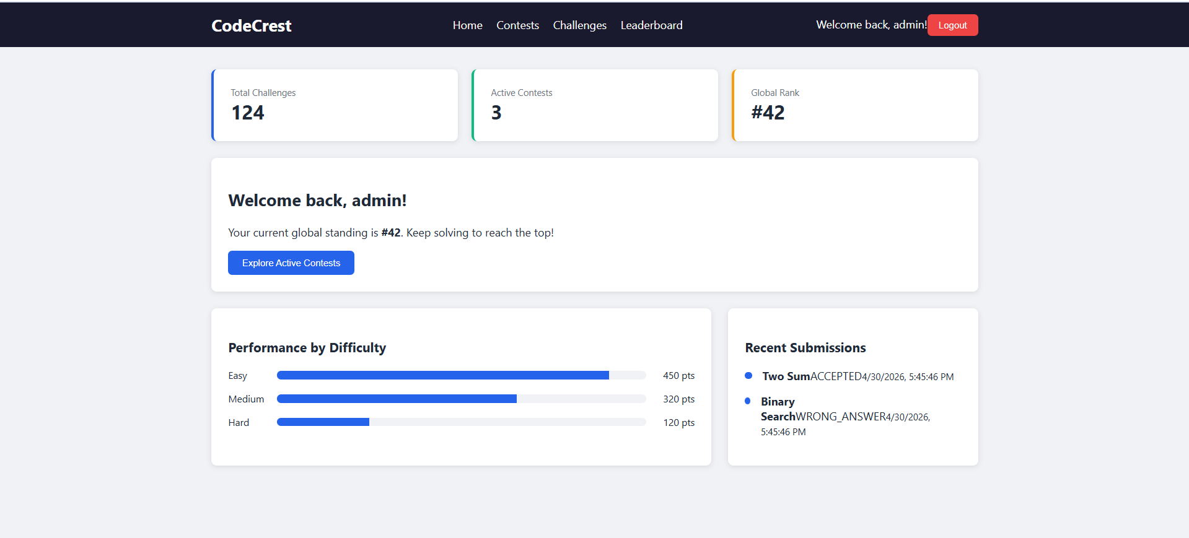

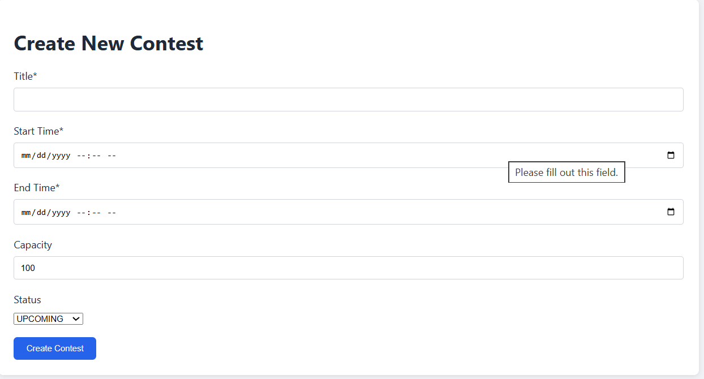
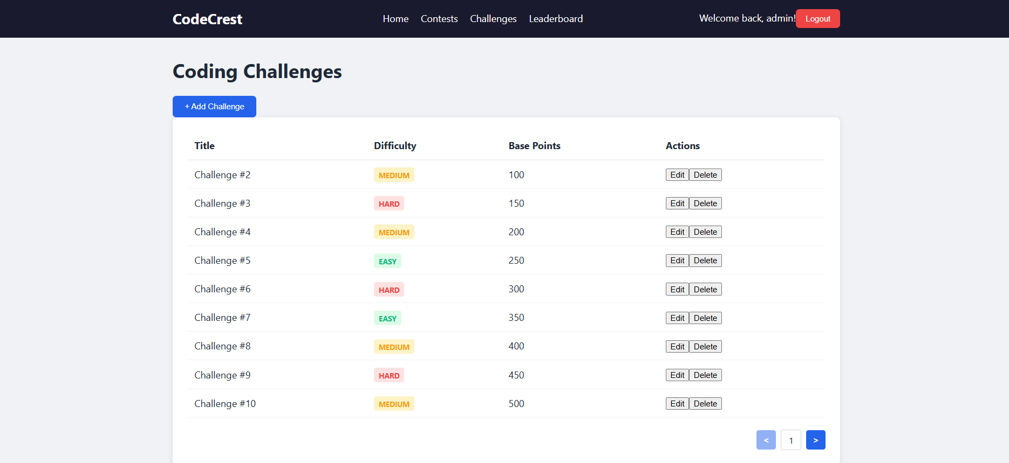

End of Documentation

